Carti Hotel Management System

Use-Case-Realization Specification: Book Rooms

Version <1.0>

Revision History

|  |  |  |  |
| --- | --- | --- | --- |
| **Date** | **Version** | **Description** | **Author** |
| <20/11/2024> | <1.0 > | <Final Version > | <Nguyen Giang Minh> |
|  |  |  |  |
|  |  |  |  |
|  |  |  |  |

Table of Contents

1. Introduction 4

1.1 Purpose 4

1.2 Scope 4

1.3 Definitions, Acronyms, and Abbreviations 4

1.4 References 4

1.5 Overview 4

2. Flow of Events—Design 4

3. Derived Requirements 5

Use-Case-Realization Specification: Book Rooms

# Introduction

## Purpose

This document details the collaborating entities involved in implementing the "Book Rooms" use case within the design model of the Carti Hotel Management System project.

## Scope

This document applies to the Carti Hotel Management System which will be developed by our development team.

## Definitions, Acronyms, and Abbreviations

None.

## References

None.

## Overview

The following section offers a detailed overview of the use case's design and associated requirements. Specifically, the flow of events design includes the development of the class diagram and sequence diagram, supported by concise textual explanations for clarity.

The following section also highlights the derived requirements essential for the successful implementation of the use case. These requirements act as critical guidelines to ensure its effective realization and functionality.

# Flow of Events—Design

The following diagrams illustrate the necessary classes and the collaborative sequence to implement the "Book Rooms" use case.

On the main page, the customer clicks the “Book Now” button, which redirects them to the Booking Page. Once on the Booking Page, the customer enters essential details such as the check-in date, check-out date, the number of guests, and any applicable promo code to initiate the room booking process. By clicking the “Searching Room” button, the redirectRoom() function navigates the user to the Room Page, and the loadRooms() function triggers the Room Controller to retrieve suitable room options by invoking the getAvailableRooms() method. The results are then displayed on the screen through the showAvailableRooms () function.

Following this, the customer can select a specific room. The Room Controller retrieves detailed information about the selected room by accessing the Room database via the getBookingInfo() method, and the information is presented on the screen using the showBookingInfo() function.

The customer proceeds to enter their personal details, which are saved to the database. After confirming their intent to book, the customer clicks the “Book&Proceed” button, initiating the validateInfo() function to verify the provided information.

If the information is valid, the Customer Controller updates the customer's information by calling the updateCustomerInfo() function, while the Room Controller updates the booking details using the updateBookingInfo() method. The user is then redirected to the Success Booking page using the redirect() function, and a confirmation message is displayed via the showSuccessBooking () function. Conversely, if the information is invalid, an error message is displayed on the screen using the displayError() function.

## Sequence diagram

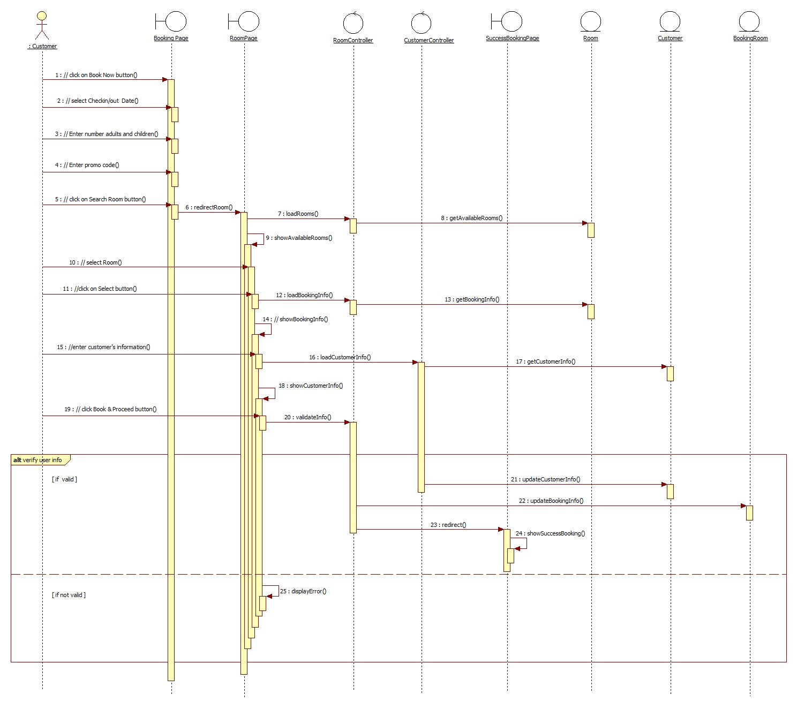

## Class diagram

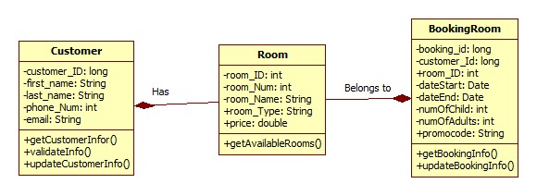

# Derived Requirements

None.